***Name:Areeb Bhatti***

***Class:IT-3A***

***ID:BIT-23F-027***

***TASK 1***

Write a Python function that draws a square using asterisks (*). The side length of the square should be provided by the user.

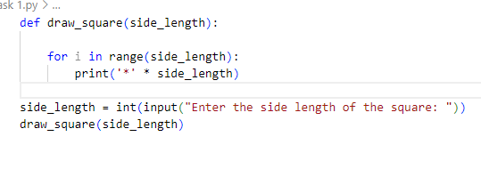

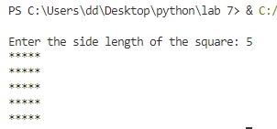

***TASK 2***

Write a Python function that takes a list of numbers as input and returns the sum of only the even numbers.

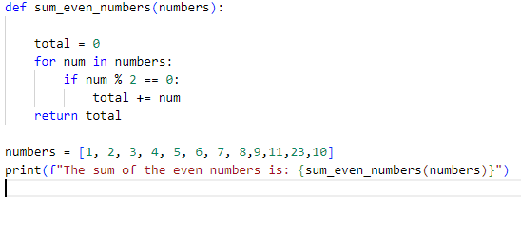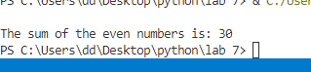

***TASK 3***

Write a Python function that takes a number as input and counts down to zero, printing each number

